# Computer Programming Lab 10

**Nabeel Ali BEE173059 Section-3**

## Activity 1

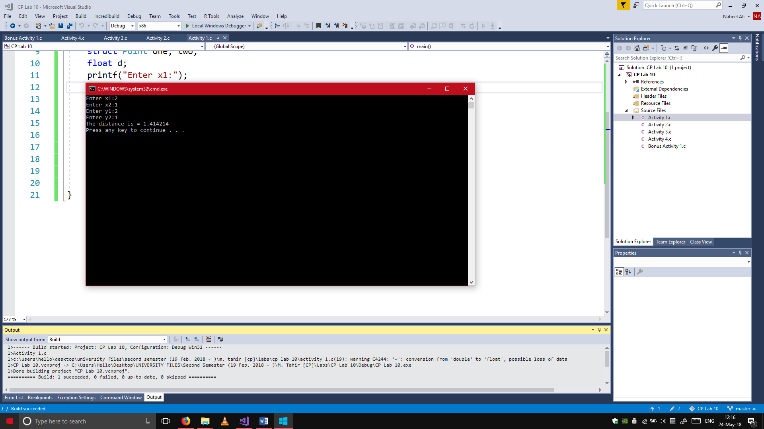#include <stdio.h>

#include <math.h>

struct Point

{

int x, y;

};

main()

{

struct Point one, two;

float d;

printf("Enter x1:");

scanf("%d", &one.x);

printf("Enter x2:");

scanf("%d", &two.x);

printf("Enter y1:");

scanf("%d", &one.y);

printf("Enter y2:");

scanf("%d", &two.y);

d = sqrt(pow((two.x - one.x), 2) + pow((two.y - one.y), 2));

printf("The distance is = %f\n", d);

}

## Activity 2

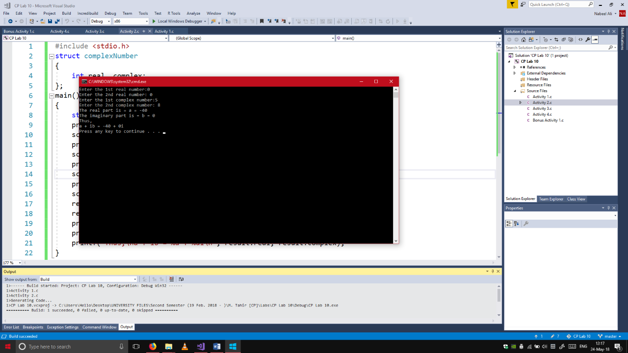#include <stdio.h>

struct complexNumber

{

int real, complex;

};

main()

{

struct complexNumber one, two, result;

printf("Enter the 1st real number:");

scanf("%d", &one.real);

printf("Enter the 2nd real number: ");

scanf("%d", &two.real);

printf("Enter the 1st complex number:");

scanf("%d", &one.complex);

printf("Enter the 2nd complex number: ");

scanf("%d", &two.complex);

result.real = (one.real * two.real) - (one.complex * two.complex);

result.complex = (one.real * two.complex) + (two.real * one.complex);

printf("The real part is = a = %d\n", result.real);

printf("The imaginary part is = b = %d\n", result.complex);

printf("Thus,\na + ib = %d + %di\n", result.real, result.complex);

}

## Activity 3

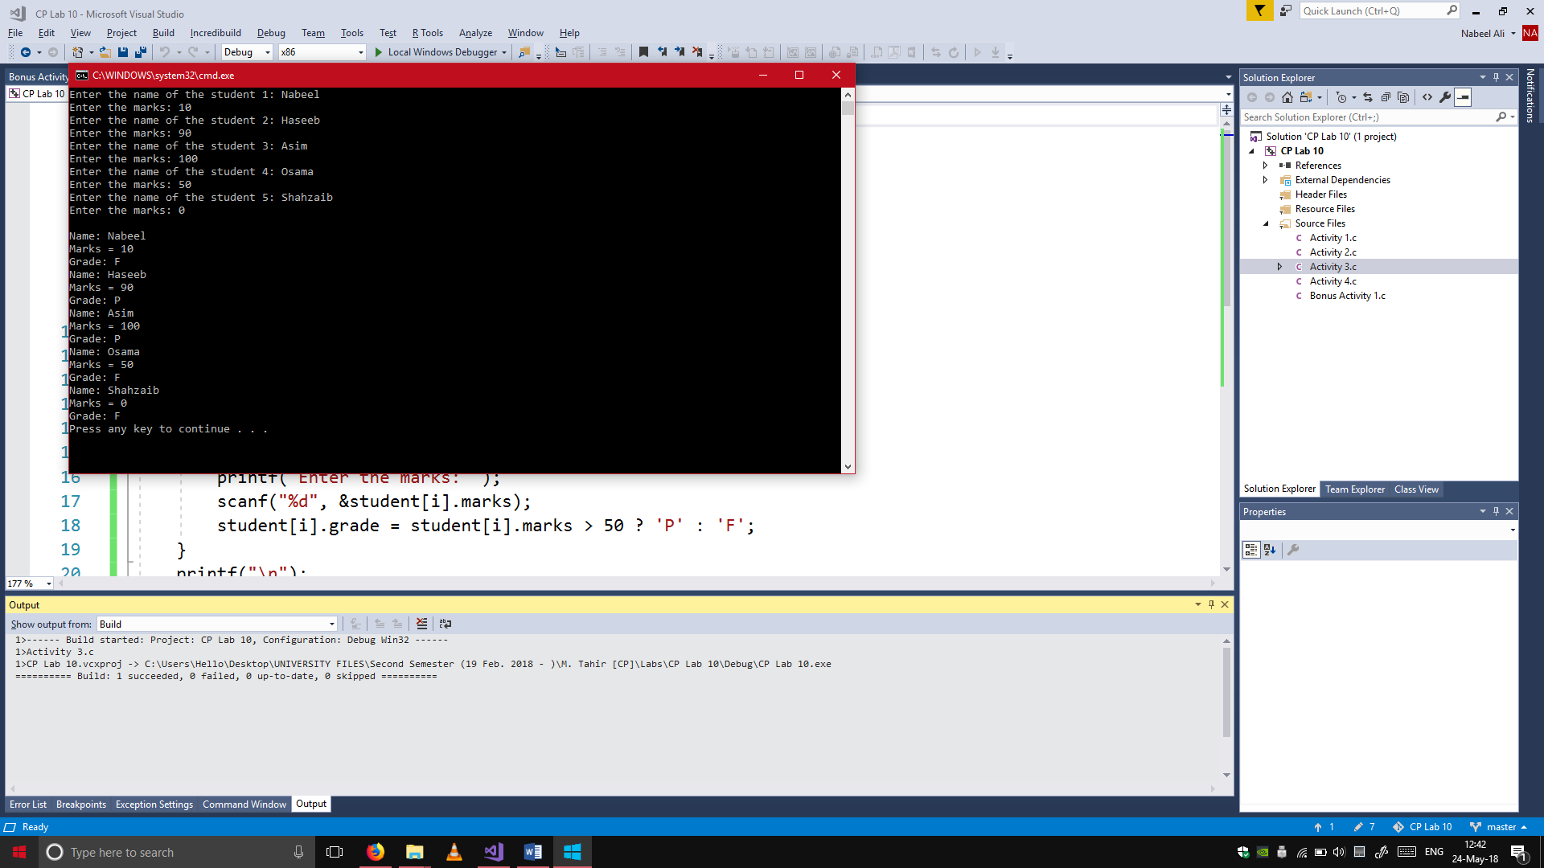#include <stdio.h>

struct Student

{

char name[20], grade;

int marks;

};

main()

{

struct Student student[5];

int i;

for (i = 0; i < 5; i++)

{

printf("Enter the name of the student %d: ", i+1);

scanf("%s", &student[i].name);

printf("Enter the marks: ");

scanf("%d", &student[i].marks);

student[i].grade = student[i].marks > 50 ? 'P' : 'F';

}

printf("\n");

for (i = 0; i < 5; i++)

{

printf("Name: %s\n", student[i].name);

printf("Marks = %d\n", student[i].marks);

printf("Grade: %c\n", student[i].grade);

}

}

## Activity 4

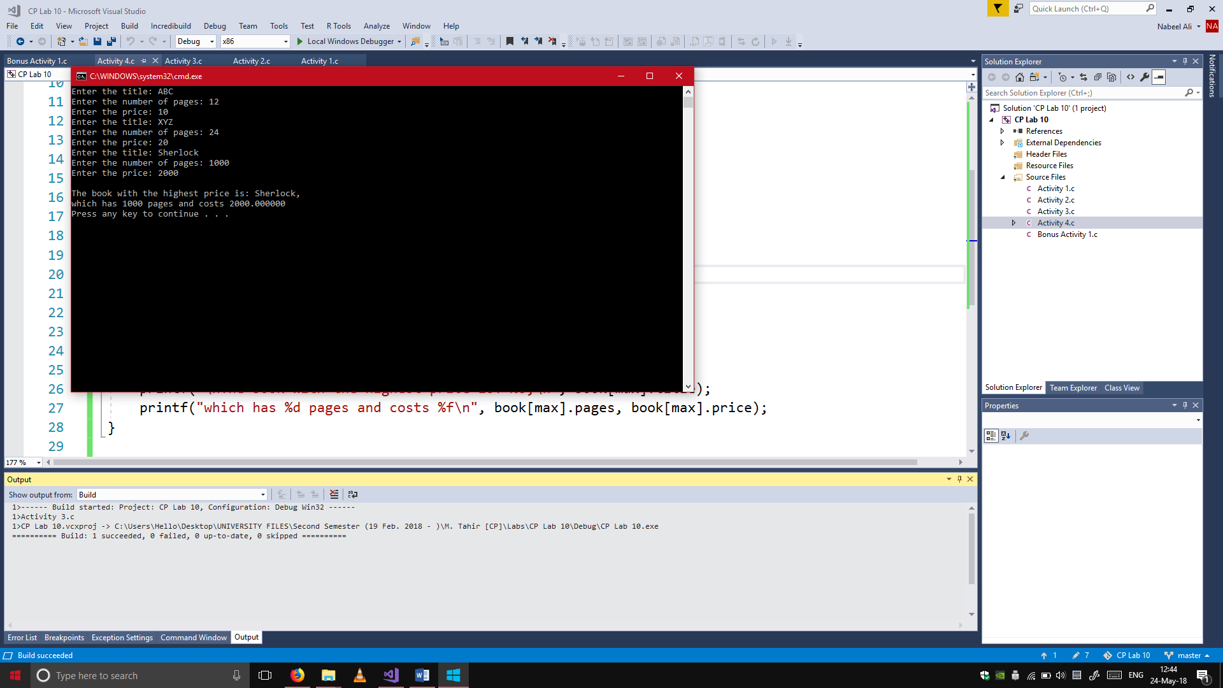#include <stdio.h>

struct Book

{

char title[20];

int pages;

float price;

};

main()

{

struct Book book[3];

int i, max = 0;

for (i = 0; i < 3; i++)

{

printf("Enter the title: ");

scanf("%s", &book[i].title);

printf("Enter the number of pages: ");

scanf("%d", &book[i].pages);

printf("Enter the price: ");

scanf("%f", &book[i].price);

max = book[i].price > max ? i : max;

}

printf("\nThe book with the highest price is: %s,\n", book[max].title);

printf("which has %d pages and costs %f\n", book[max].pages, book[max].price);

}

## Bonus Activity 1

#include <stdio.h>

struct Patient

{

char name[20];

int ID, numberofvisits;

};

main()

{

struct Patient patient[3];

int i, compare, check = 0;

for (i = 0; i < 3; i++)

{

printf("Enter the name of patient %d: ", i + 1);

scanf("%s", &patient[i].name);

printf("Enter the ID of the patient: ");

scanf("%d", &patient[i].ID);

printf("Enter the number of visits: ");

scanf("%d", &patient[i].numberofvisits);

}

printf("Enter the patient ID to search: ");

scanf("%d", &compare);

for (i = 0;i < 3;i++)

{

if (compare == patient[i].ID)

{

check = 1;

break;

}

}

if (check == 1)

{

printf("Name of patient: %s\n", patient[i].name);

printf("Number of visits: %d\n", patient[i].numberofvisits);

printf("ID of the patient: %d\n", patient[i].ID);

}

